

Azure D1①_900

1- Explore Core Data concept:

key_value, Document DB, Graph DB

Relational DB is some types of DB.

Transaction DB.

Ex⑧Banking data.

It must deal to ACID.

Automicity:

E⑧xecute in single unit

Fail or Pass.

consistency. Take data from valid

state to another state.

Isolatation multiple transaction occur Independently.

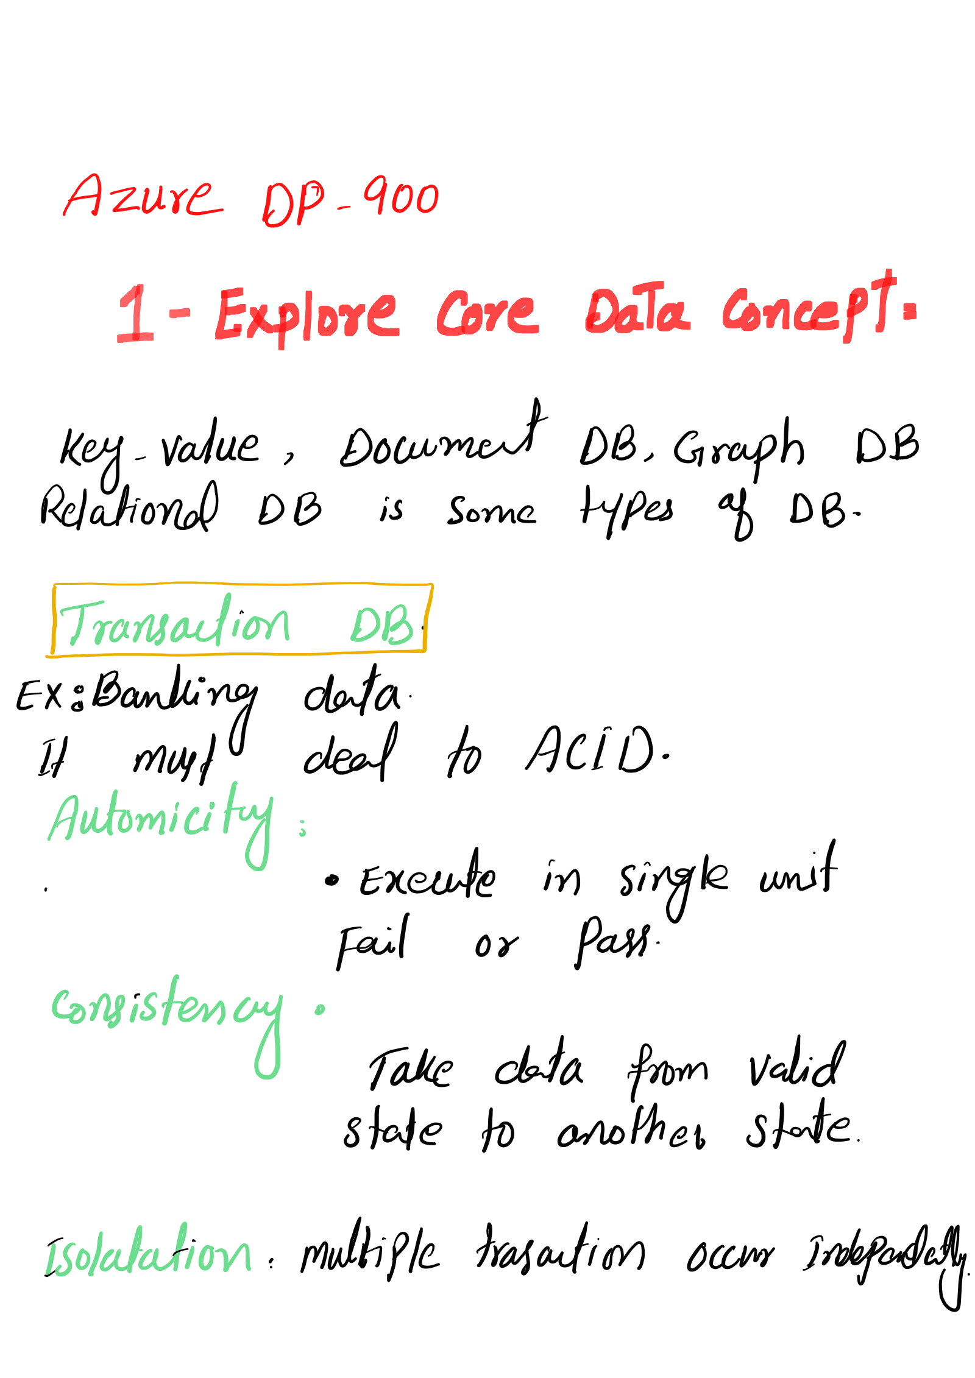



Durability'commited transactions remain

Commited even system failure

occur.

Distributed DB.

Data store in different location. on

same or different network.

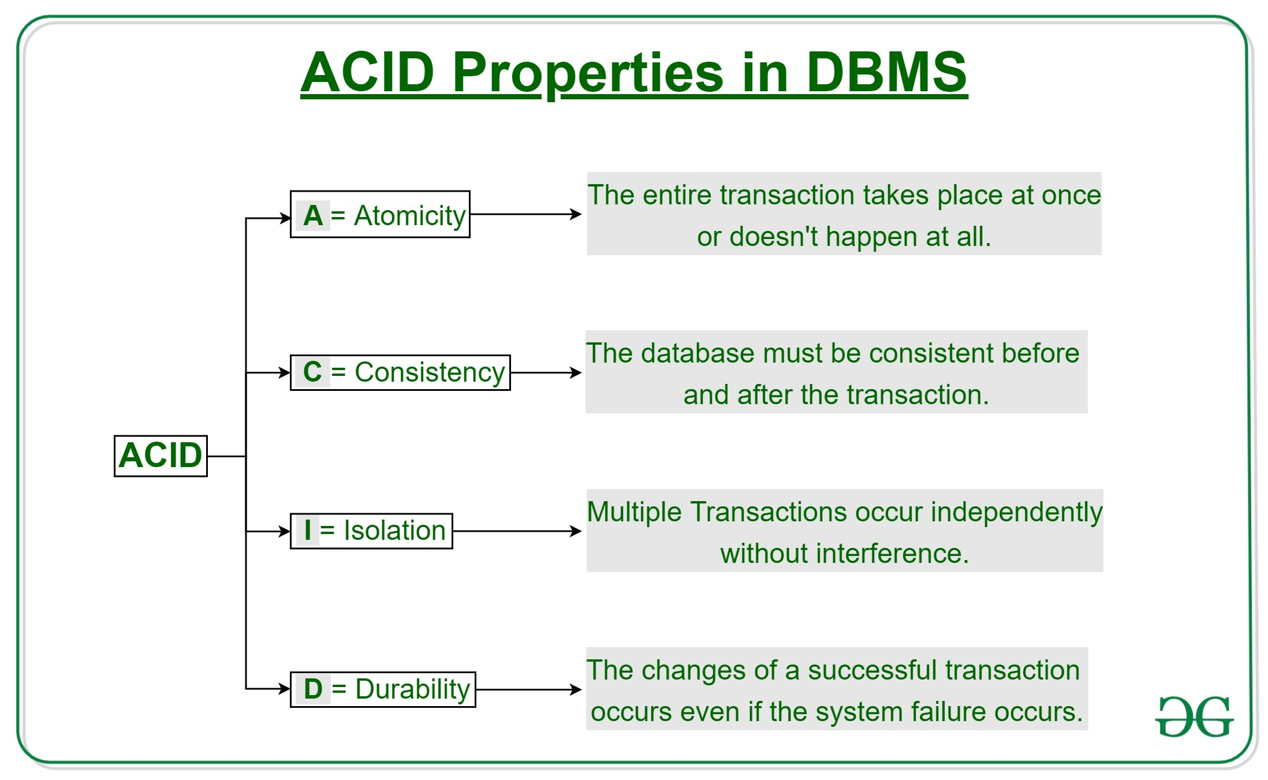

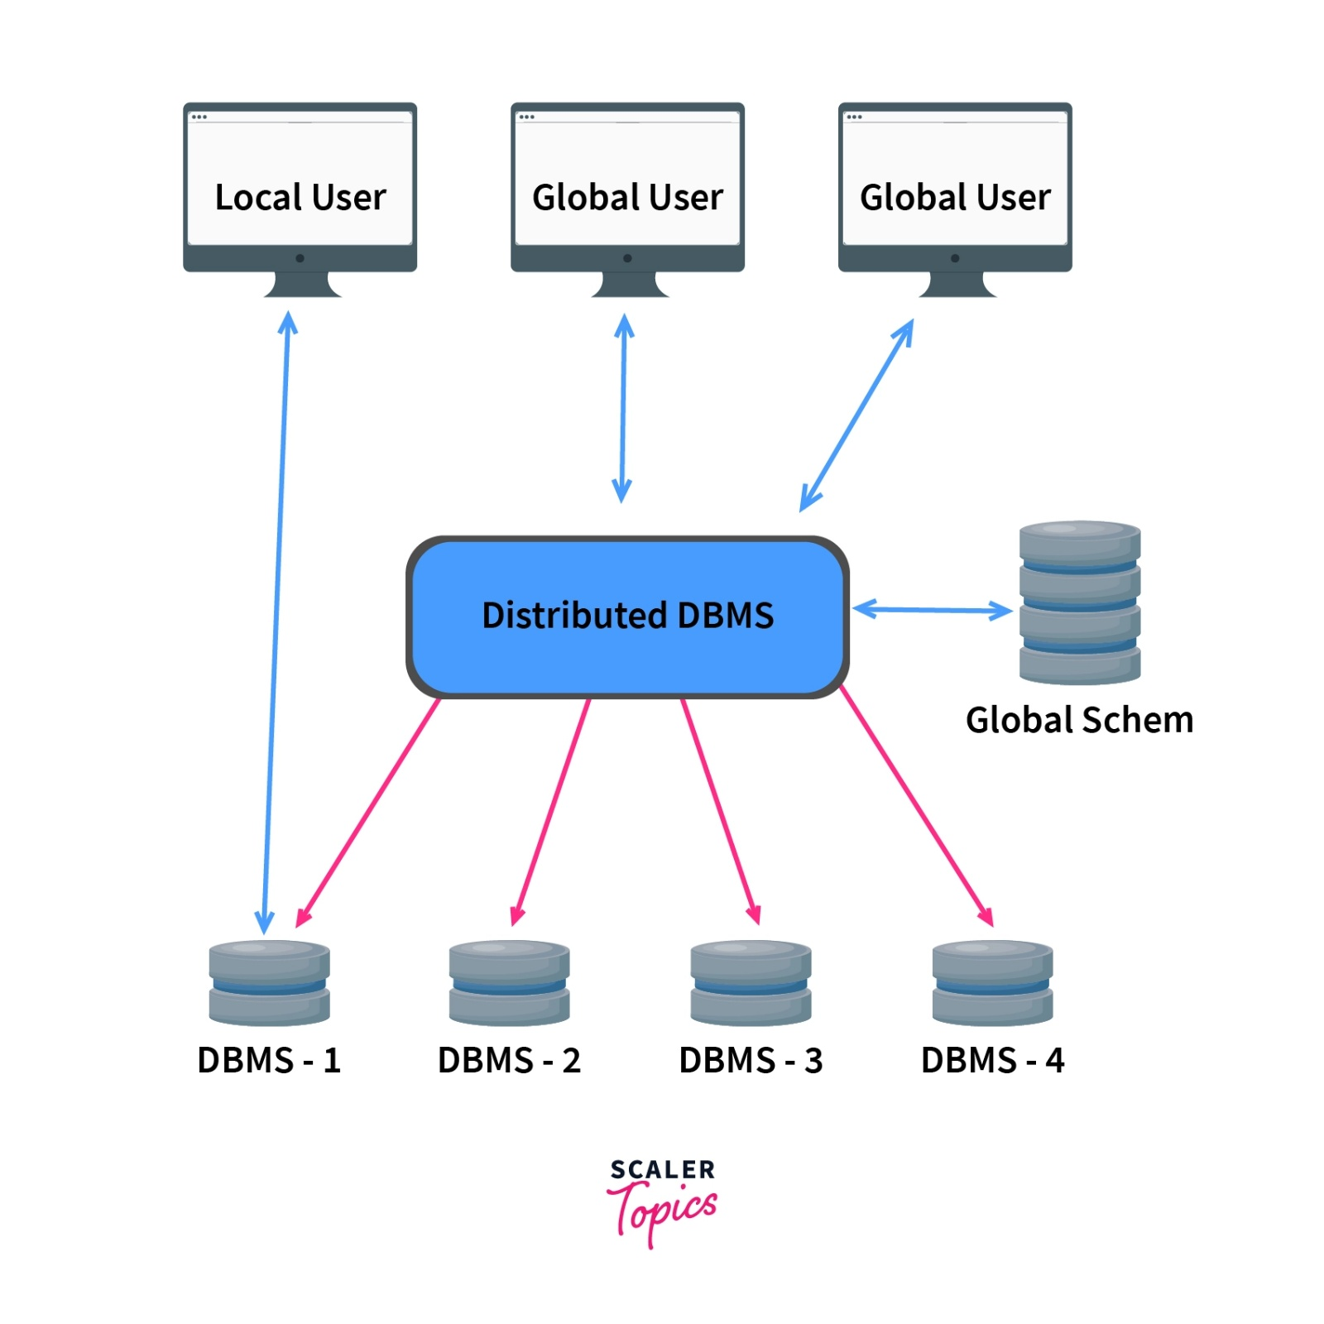

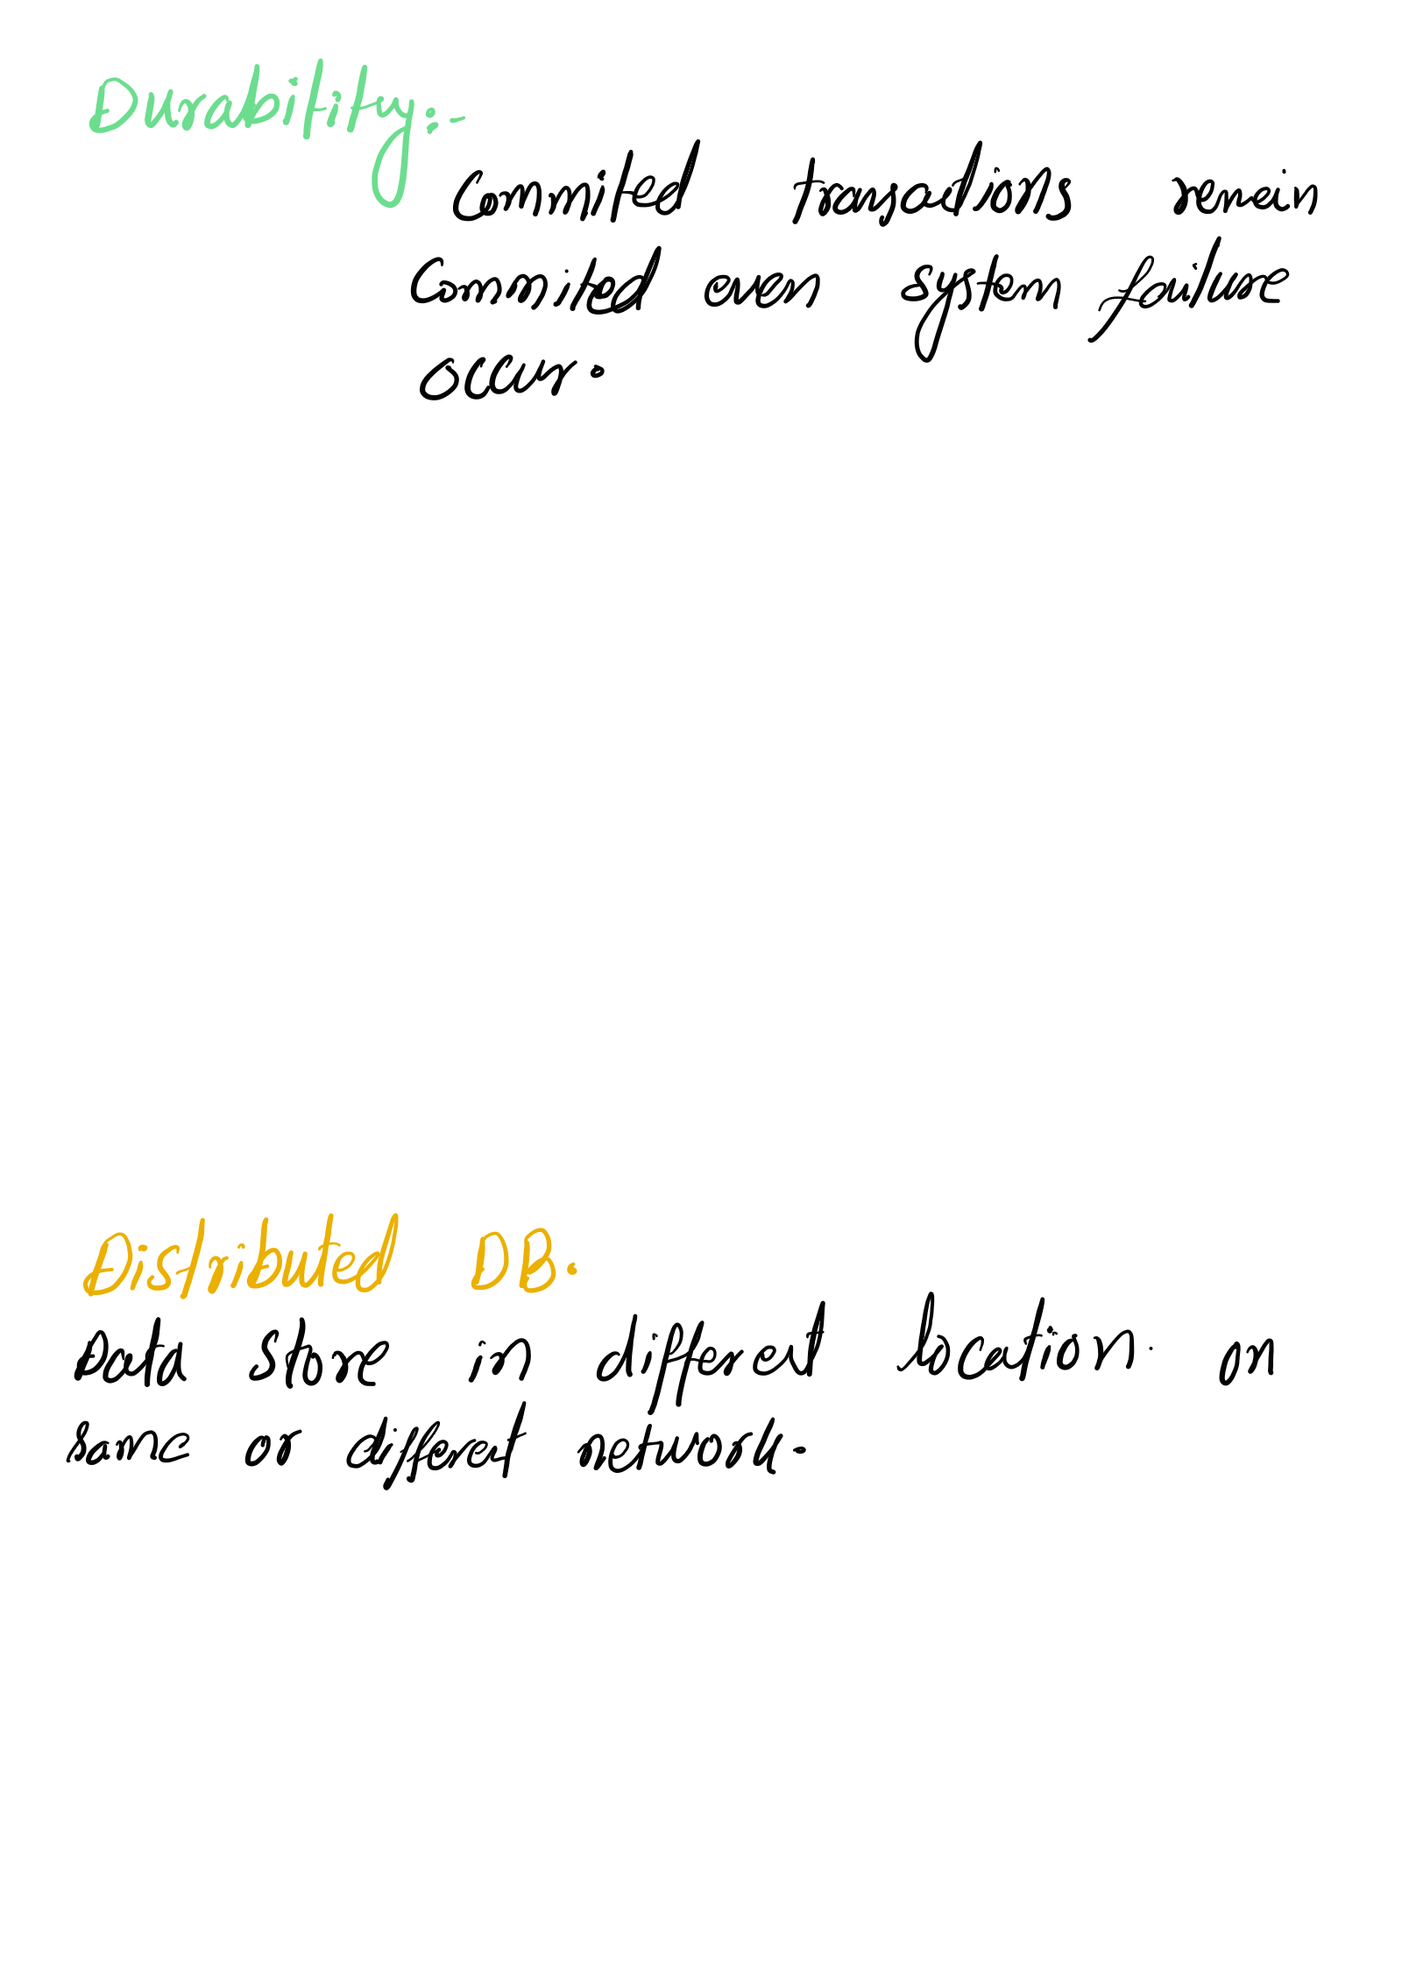







Batch and stream process:-

•data in the form of group is Batch.

. apply OLAP.

•Data warehouse solution, Monthly andysis

Stream OLTP. transactional data. New incoming

data,

EX: Stock price

online gaming company

Real-estate website.

Batch process at

once

Stream. process as

's Bis it come

Role and Responsibilities in

Data:

• Data Administrator,

• Handle data

o Modify DB Structure

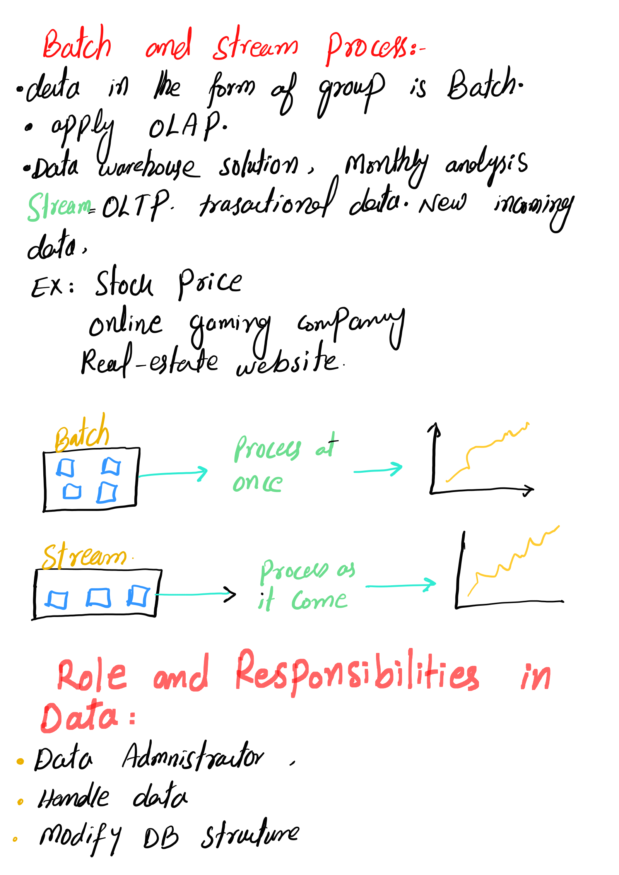



control and monitoring

Backup database

Data.replication.

...

I nstall and upgradeB server.

EX- Azure Data studio

SQL Server Margret Stuelio.

Relational and Non relational data.

Entity, field, Table. Name

AN Primary key: Identity

customer T-*orders

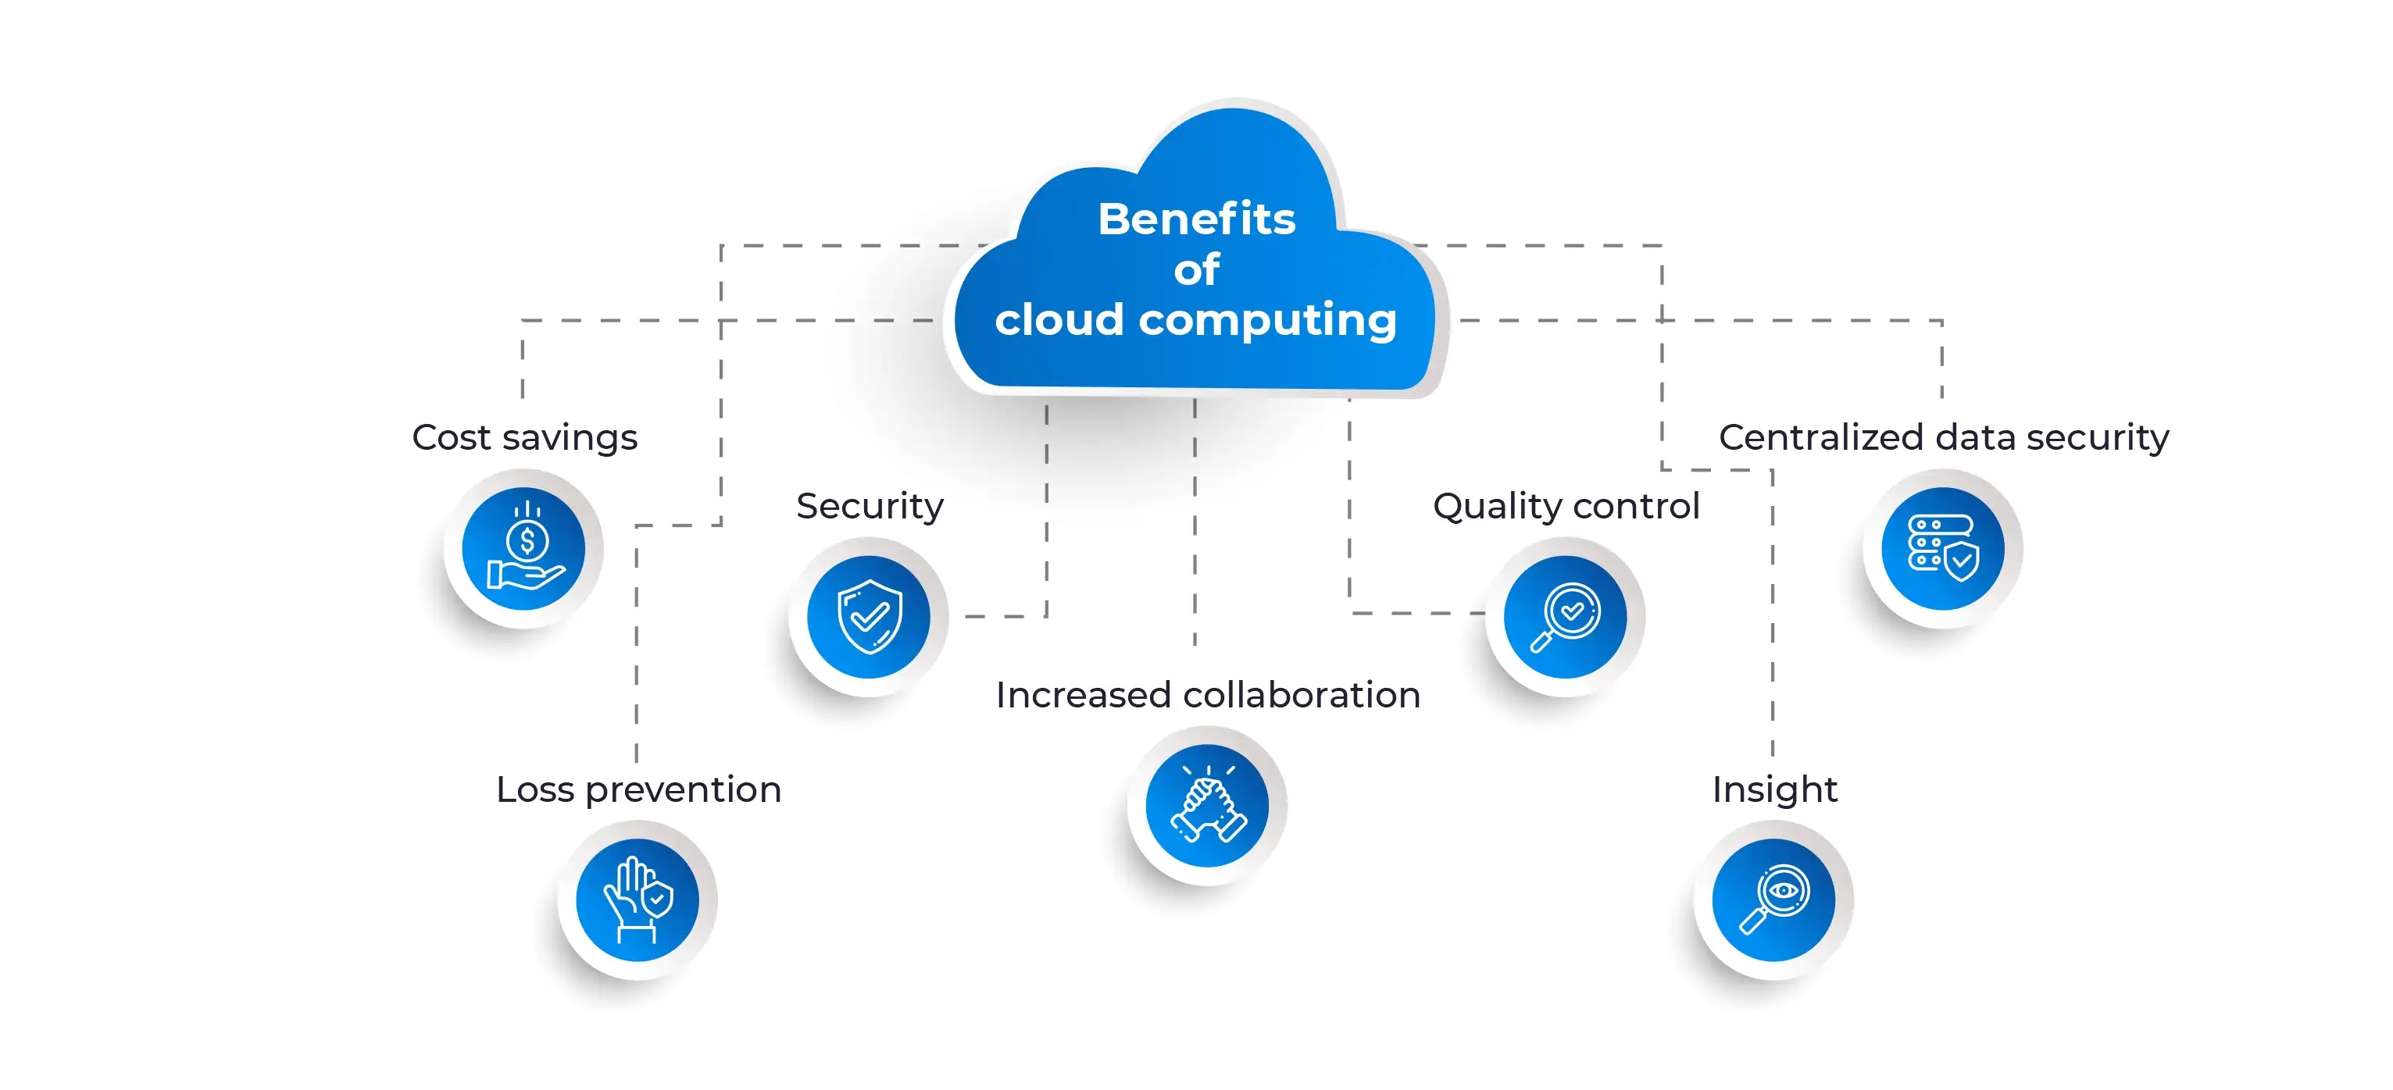

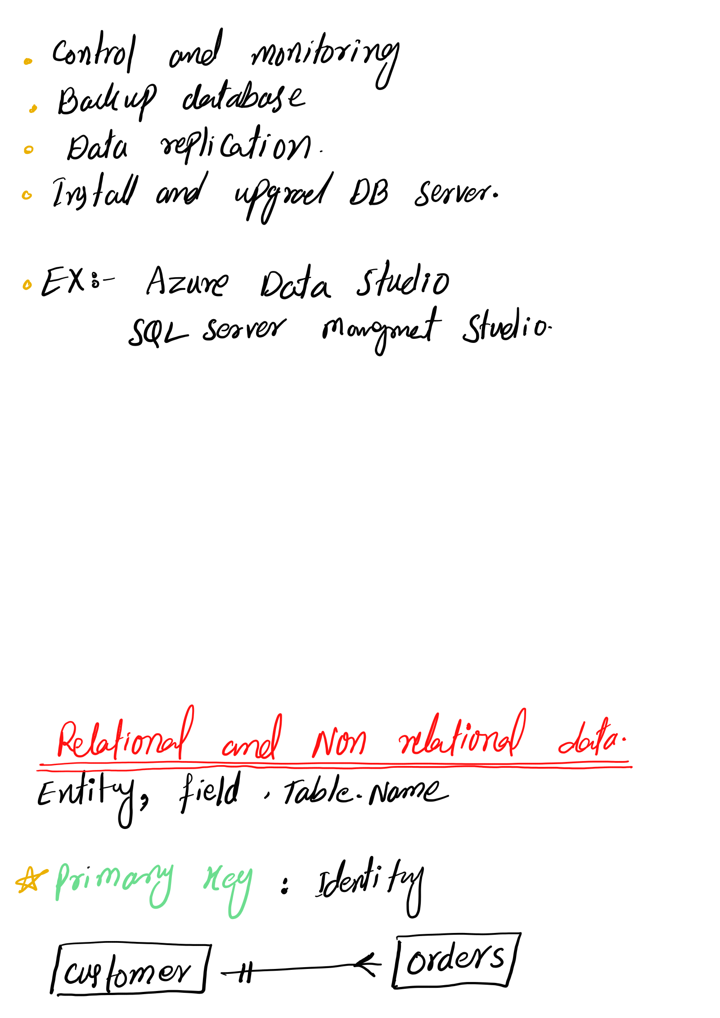





* Foreign key_

Primary key in another table called

foreign key.

As cluster Index./Non Cluster Index.

• Insert data in table with order Formate.

. Fast search

. primary key create to creat cluster

automatically.

ID Name

A

B

;

*VIEW:_

Immediate access to relative destao

A virtual Table.

"Create VIEW as

select Name From mytable;

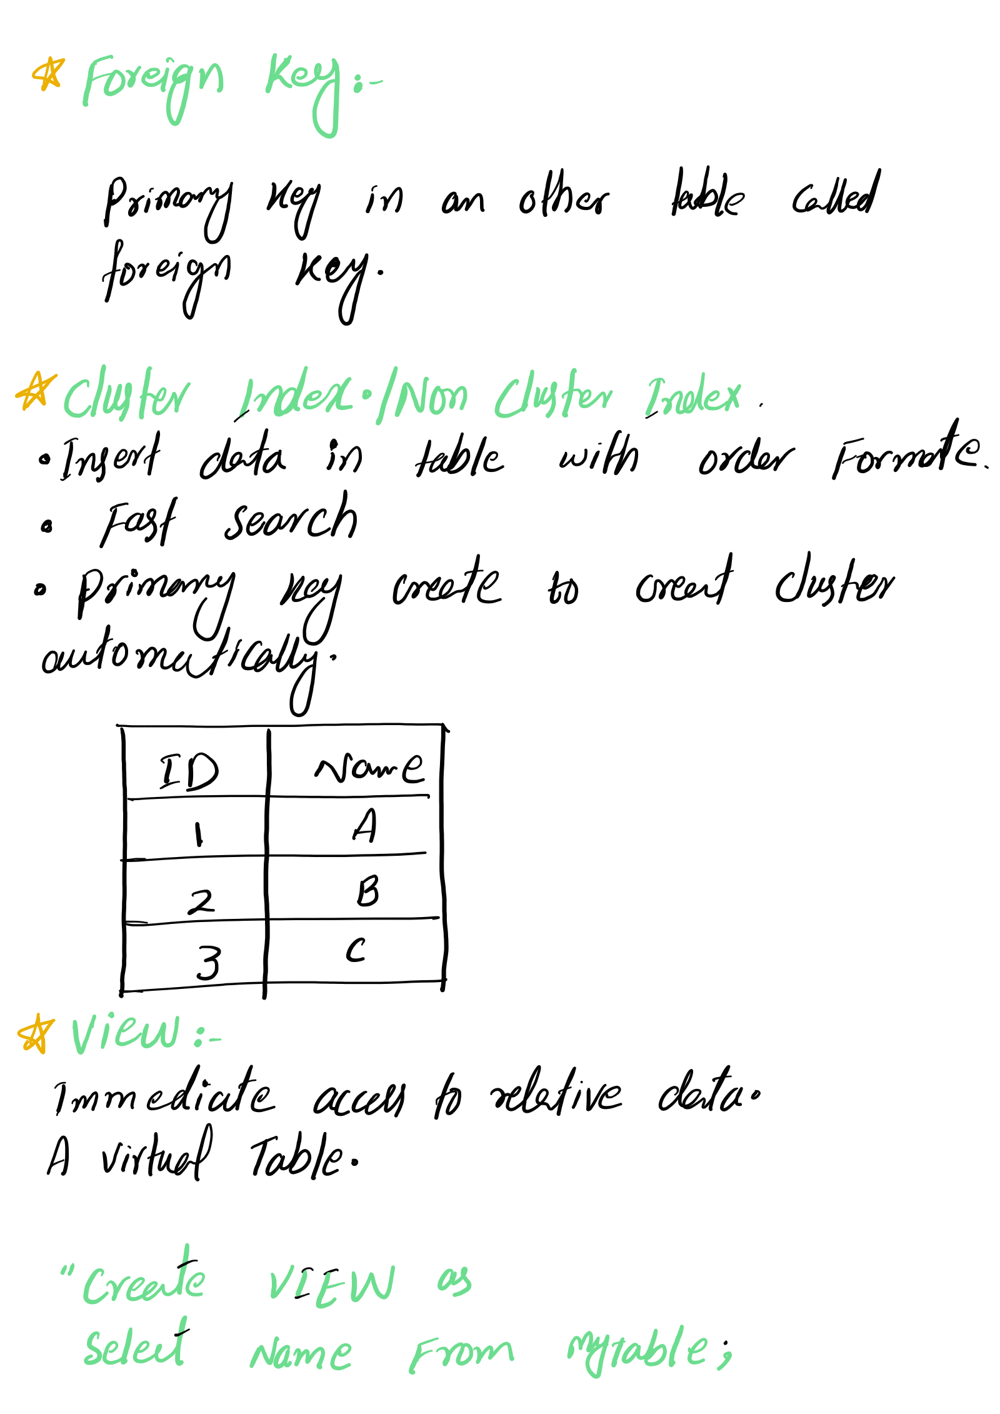



Non- Relational

unstructured data.

/

